FOCCUS®
WEBSITE UPDATE KIT
Approved descriptions, links, terminology, and instructions
for websites and printed materials
PURPOSE
Please use this kit to update FOCCUS® descriptions and official logos and add a working clickable link back to FOCCUS on your website. Both updated content and a clickable link are requested. Use https://foccusinc.com/ for general information or https://foccusinc.com/couples/ for pages guiding couples. In printed materials, show foccusinc.com.
Building Holy, Happy, and Healthy Marriages
FOCCUS® Marriage Ministries
An apostolate of the Archdiocese of Omaha
https://foccusinc.com/
Updated November 1, 2026

How to Use This Kit
Choose the section that best matches the space available and the people receiving the information. The approved copy may be used on websites and in printed materials for facilitators, clergy, couples, parishioners, and ministry leaders. You may include your own local registration steps, fees, contact person, and parish or diocesan requirements after the approved FOCCUS® description. For every website update, include a clickable link to the official FOCCUS website as well as the updated description and logo.
One-sentence description: For a directory, bulletin announcement, flyer, resource list, or brief webpage.
Short description: For a parish marriage preparation page, brochure, bulletin insert, facilitator or clergy resource, or program overview.
Full webpage copy: For a dedicated FOCCUS® page on a parish, diocesan, or organizational website. Sections may also be adapted for longer printed program materials while preserving the approved wording.
How It Works: For a couple-facing webpage, handout, brochure, welcome packet, or other explanation of what to expect.
Terminology and links: For staff, communications teams, website administrators, and anyone preparing printed materials.

Using This Copy in Printed Materials
The approved descriptions in this kit may be used in parish and diocesan bulletins, brochures, flyers, posters, program guides, event materials, facilitator packets, clergy resources, couple handouts, welcome packets, and other printed communications.
Select the description that fits the available space and the intended reader. Materials for facilitators or clergy may include local procedures and ministry contacts. Materials given to couples should explain FOCCUS® clearly, avoid technical or confidential facilitator information, and provide the appropriate local next step.
When printed materials cannot include a clickable link, use the complete address foccusinc.com. Before printing or reprinting, confirm that local names, dates, fees, contact information, registration instructions, and FOCCUS® descriptions remain current.

Required Brand Basics
- Write FOCCUS® in all capital letters and include the registered trademark symbol on the first prominent use.
- Use the full name “FOCCUS® Marriage Ministries” when referring to the organization.
- Describe FOCCUS® as a relationship discovery inventory and facilitated conversation process—not a test, survey, questionnaire, evaluation, or compatibility assessment.
- Do not state or imply that couples pass, fail, receive a compatibility score, or are approved or denied for marriage based on the inventory.
- Include a clickable link online: link the words “FOCCUS® Marriage Ministries” to https://foccusinc.com/. For a page specifically guiding couples, use https://foccusinc.com/couples/. In printed materials, show foccusinc.com. Couples should still follow their local registration instructions.

Approved Copy
OPTION 1 — ONE-SENTENCE DESCRIPTION
FOCCUS® Marriage Inventories are research-based, faith-centered relationship discovery inventories and facilitated conversation processes that help couples better understand one another and build holy, happy, and healthy marriages.

OPTION 2 — SHORT DESCRIPTION
FOCCUS® Marriage Inventories are research-based, faith-centered relationship discovery inventories and facilitated conversation processes for marriage preparation, enrichment, and lifelong support. Available in 28 languages, they help couples recognize their strengths, better understand one another, and explore important topics with a trained FOCCUS® Facilitator. FOCCUS® inventories are not tests and do not have passing or failing scores. Learn more at foccusinc.com.

OPTIONAL HIGHLIGHT — GLOBAL ACCESS
Available in 28 languages, FOCCUS® Marriage Inventories help parishes, dioceses, churches, ministries, and organizations serve couples from diverse cultural and linguistic backgrounds. Visit foccusinc.com for current language availability.

Full Webpage Copy
The following copy may be placed on a dedicated FOCCUS® webpage. It may also serve as source copy for longer printed materials. Add your local process and contact information in the designated section.

FOCCUS® Pre-Marriage Inventory
FOCCUS®—Facilitating Open Couple Communication, Understanding and Study—is a research-based, faith-centered relationship discovery inventory and facilitated conversation process.
Each partner completes the inventory independently. A trained FOCCUS® Facilitator then guides the couple through private conversations about their relationship, helping them recognize their strengths and explore topics that may benefit from additional discussion.
FOCCUS® Marriage Ministries offers a family of 10 inventories designed for different relationship stages, circumstances, and pastoral needs—from marriage preparation through enrichment and lifelong support. The appropriate inventory can be selected to fit the couple’s situation and the purpose of the ministry offering it.
FOCCUS® addresses important areas of married life, including communication, conflict resolution, finances, faith, family of origin, intimacy, parenting, values, expectations, and commitment.
FOCCUS® Marriage Inventories are available in 28 languages, helping parishes, dioceses, churches, ministries, and organizations serve couples from diverse cultural and linguistic backgrounds.
FOCCUS® is not a test, a measure of compatibility, or a predictor of marital success. There are no “passing” or “failing” scores. Its purpose is to foster honest conversation, greater understanding, and thoughtful preparation for a lifelong marriage.
FOCCUS® Marriage Ministries has served couples since 1985 and is an apostolate of the Archdiocese of Omaha.
Discover more about your relationship. Discuss what matters. Deepen your commitment.
Learn more about FOCCUS® Marriage Ministries: https://foccusinc.com/ (make the organization name a clickable link when publishing online).

Our Local FOCCUS® Process
Who to contact | [Name, title, phone, and email]
How to begin | [Registration or parish instructions]
When to begin | [Recommended number of months before the wedding]
Local fee, if applicable | [Amount and payment instructions]
Additional requirements | [Marriage preparation classes, meetings, documents, or other steps]

How FOCCUS® Works
1. Your facilitator registers you. Your parish, church, organization, or FOCCUS® Facilitator will provide instructions for completing the inventory.
2. Each partner responds independently. Partners complete the inventory separately and answer honestly based on their own thoughts, experiences, and expectations.
3. A personalized Couple Report is created. Responses help identify strengths, areas of agreement, uncertainty, and topics that may benefit from further conversation.
4. You meet with your facilitator. A trained FOCCUS® Facilitator guides private, respectful conversations based on the couple’s responses.
5. You strengthen your foundation for marriage. The process helps couples communicate more openly, understand one another more deeply, and prepare thoughtfully for married life.

Approved Terminology
Consistent language protects couples from misunderstanding the purpose of FOCCUS® and helps present the ministry accurately.
Please use | Please avoid
FOCCUS® Marriage Inventories | FOCCUS test
Relationship discovery inventory and facilitated conversation process | Test, survey, questionnaire, evaluation, or compatibility assessment
Strengths and topics for further conversation | Strengths and weaknesses
Trained FOCCUS® Facilitator | Test administrator or scorer
Personalized Couple Report | Test results, grade, or score
No passing or failing scores | Passes or fails FOCCUS
Each partner completes the inventory independently | The couple completes it together
FOCCUS® Marriage Ministries | FOCCUS Inc. when referring to the ministry
FOCCUS® | FOCCUS©, F.O.C.C.U.S., Foccus, or FOCUS

Required Website Links
Please complete both steps: update your FOCCUS description and official logo, and include a working clickable link back to FOCCUS. A name, logo, or web address displayed as plain text does not replace the clickable link.
Link “FOCCUS® Marriage Ministries” to https://foccusinc.com/ for general information, or to https://foccusinc.com/couples/ on pages guiding couples. If you display our logo, link it to the same destination where your website permits. Keep local registration instructions and inventory-system links separate.
After publishing, test the link on desktop and mobile and send the updated webpage address to foccus@foccusinc.com so we can confirm the update.

Approved Links
FOCCUS® Marriage Ministries: https://foccusinc.com/
Primary link for general information.
Information for Couples: https://foccusinc.com/couples/
Recommended link for engaged or married couples learning about FOCCUS®.
FOCCUS® Inventory System: https://foccusinventory.com/
Use only when your local instructions direct registered couples or facilitators to the inventory system.

Trademark and Editorial Style
- Use FOCCUS® on the first prominent appearance in a heading and on the first appearance in body copy. FOCCUS may be used without the symbol in later references within the same document or webpage.
- Do not alter the spelling, capitalization, or appearance of the FOCCUS® name.
- Do not use the copyright symbol (©) as a substitute for the registered trademark symbol (®).
- When space permits, identify FOCCUS® Marriage Ministries as an apostolate of the Archdiocese of Omaha.
- Do not reproduce inventory items, Couple Reports, confidential facilitator materials, or other copyrighted program content on a public website or in printed materials.

Official FOCCUS® Logos
Use only the official logo files supplied by FOCCUS® Marriage Ministries. The logos may be used on parish, diocesan, church, ministry, and organizational websites and in printed materials that accurately identify or promote participation in FOCCUS® programs.

Vertical Logo
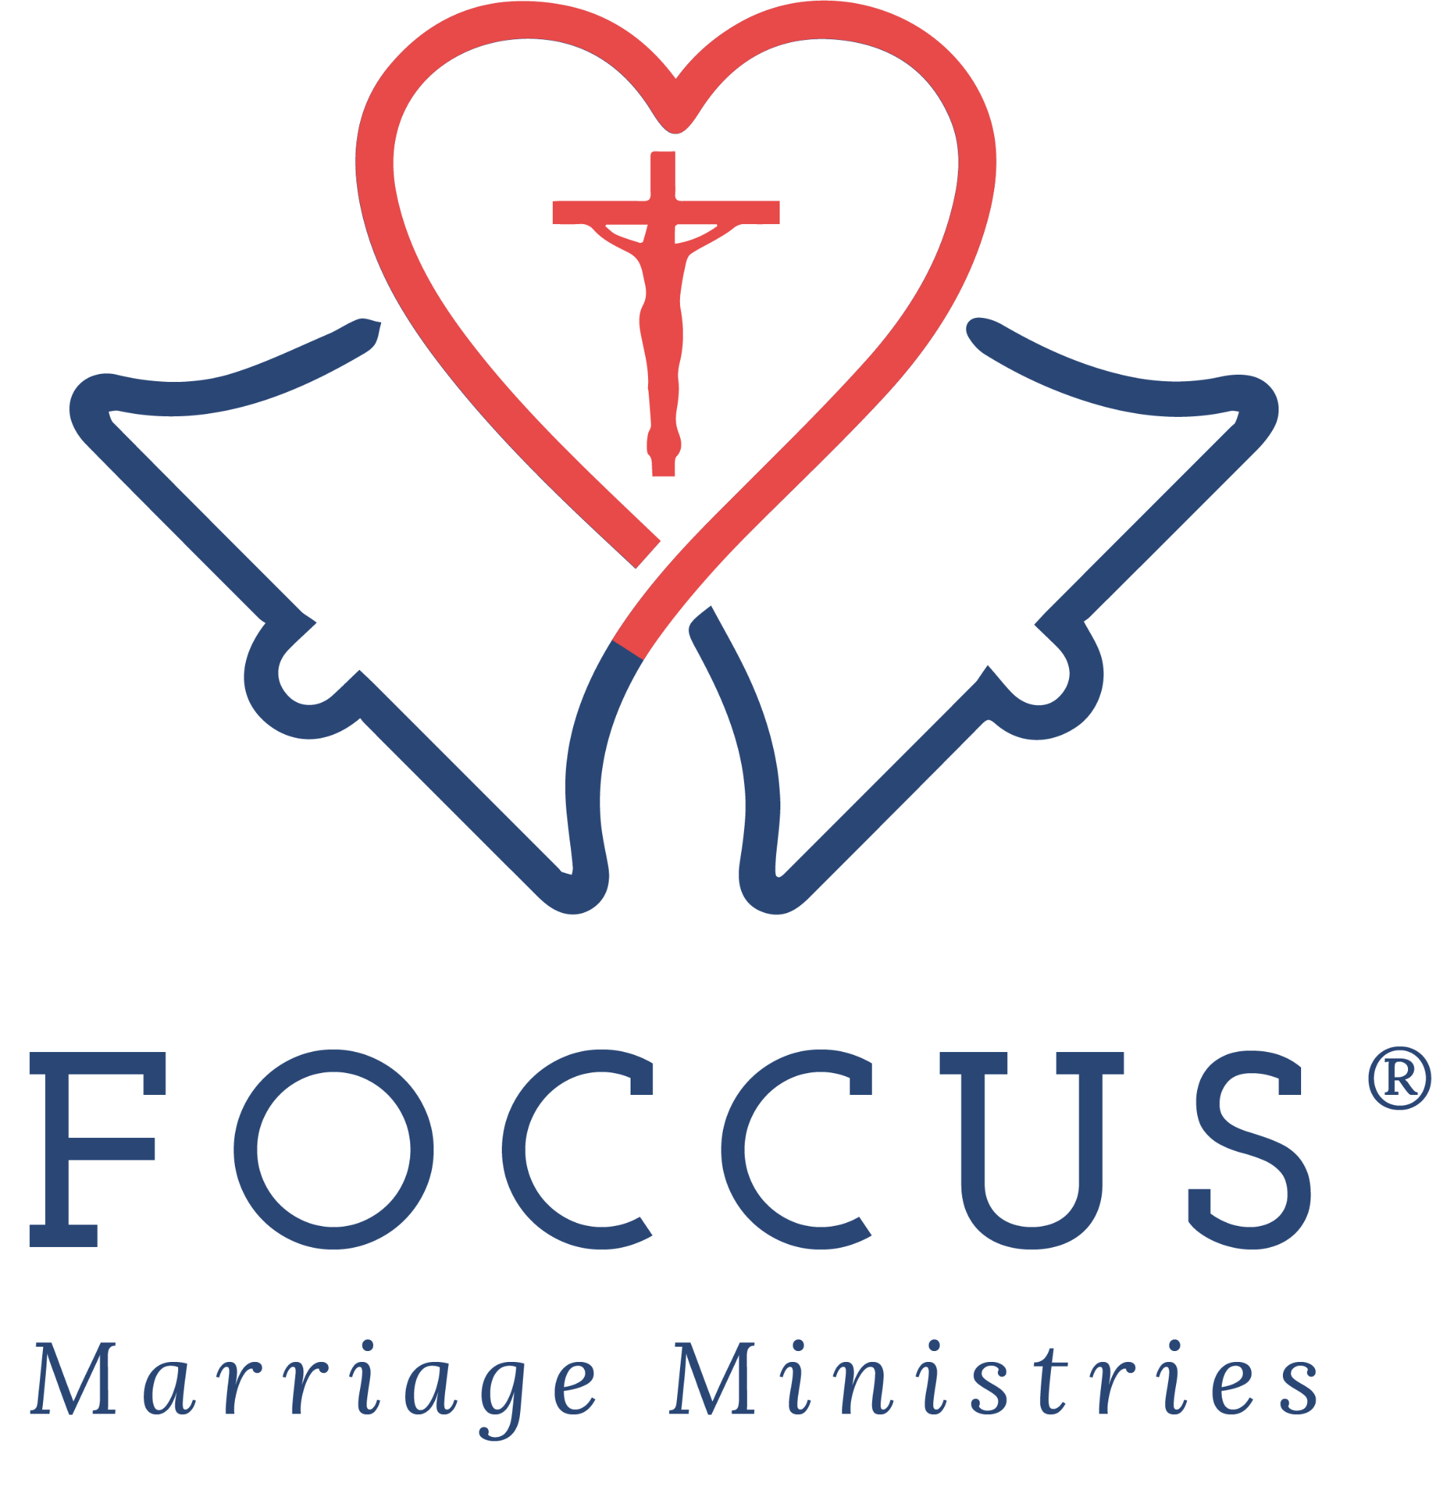
Recommended for square or portrait-oriented spaces, including flyers, bulletin inserts, program covers, social graphics, and centered website layouts.
Supplied file: FOCCUS_Official_Vertical_Logo.png

Horizontal Logo

Recommended for website headers, email headers, banners, letterhead, brochures, event materials, and other wide-format placements.
Supplied file: FOCCUS_Official_Horizontal_Logo.png

Logo Use Requirements
- Keep the logo’s original proportions. Do not stretch, compress, rotate, skew, or redraw it.
- Do not alter the colors, fonts, wording, symbol, or registered trademark mark.
- Maintain clear space around the logo so it remains distinct from surrounding text and graphics.
- Use a size that keeps all logo details and wording legible.
- Place the full-color logo on a white or light, uncluttered background whenever possible.
- Do not place text, photographs, patterns, or other graphics over the logo.
- The logo may identify participation in or use of FOCCUS® programs; it may not be used to imply ownership of, certification by, or authority to alter FOCCUS® materials.

Website and Printed Materials Update Checklist
☐ Replace outdated FOCCUS descriptions on websites and in printed materials with one of the approved options in this kit.
☐ Confirm that FOCCUS® is described as a relationship discovery process—not a test, survey, questionnaire, evaluation, or compatibility assessment.
☐ Remove references to passing, failing, grades, scores, approval, or denial of marriage.
☐ Remove outdated descriptions of editions, languages, manuals, scoring methods, pricing, and registration procedures.
☐ If mentioning language availability, use “available in 28 languages” and direct readers to foccusinc.com for current information.
☐ Include and test a clickable “FOCCUS® Marriage Ministries” link to https://foccusinc.com/, or https://foccusinc.com/couples/ for couple-facing information. Use foccusinc.com in print.
☐ Keep local parish or diocesan instructions clearly separate from the general FOCCUS® description.
☐ Confirm that local contact names, email addresses, phone numbers, fees, and timelines are current.
☐ Use FOCCUS® correctly and replace FOCCUS©, F.O.C.C.U.S., Foccus, or FOCUS.
☐ Remove any publicly reproduced inventory questions or confidential facilitator materials.
☐ Review printed materials for the intended audience—facilitators, clergy, couples, or the general public—and remove confidential or audience-inappropriate content.
☐ Before printing or reprinting, verify local contact information, dates, fees, registration steps, and web addresses.
☐ Ask your communications or website team to review webpages on desktop and mobile devices and proof printed materials before distribution. Send the published webpage address to foccus@foccusinc.com after the update.

Optional Attribution
FOOTER OR RESOURCE-LIST ATTRIBUTION
FOCCUS® Marriage Ministries is an apostolate of the Archdiocese of Omaha dedicated to helping couples build holy, happy, and healthy marriages through preparation, enrichment, and lifelong support. Visit foccusinc.com.

Questions or Assistance
FOCCUS® Marriage Ministries
3033 N. 93rd St.
Omaha, Nebraska 68134 USA
Toll free: 877-883-5422
foccus@foccusinc.com
https://foccusinc.com/
Thank you for helping facilitators, clergy, couples, and communities receive accurate, current information about FOCCUS® and for sharing in the mission of building holy, happy, and healthy marriages.

